Does your GP know you look after someone?
If you help a family member, friend or neighbour because of their physical, mental ill health, frailty, learning disability or substance misuse ……. Then you are a Carer?
- Your GP does not automatically know your situation or understand how the care you gives affects your life
- Carers are at a higher risk of becoming ill themselves
- Once the surgery knows you are a Carer we will be able to consider your specific needs

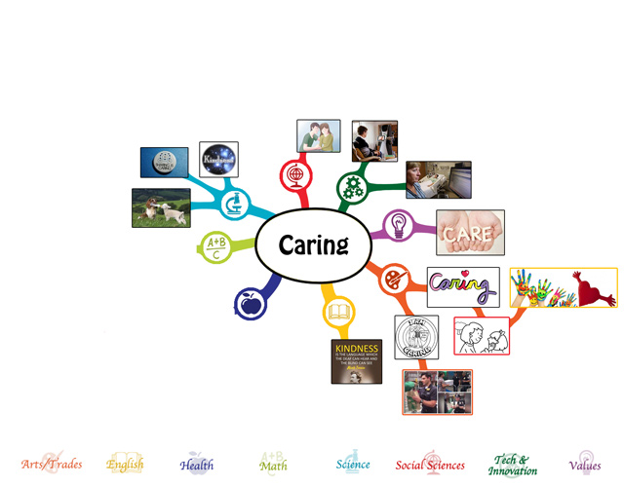

Why register as a Carer with your GP Practice?
- It will be recorded in your records – this is important in case you become unwell and help protect the person you are caring for
- You will be offered an annual Flu Jab
- You will be entitled to an annual health check
- Where possible you may be offered more flexible appointments
- Help you get the advice on treatment for the person you look after
- Provides a gateway to all kinds of information and support including respite
- With your permission we will refer you to Northamptonshire Carers who can offer you additional support including emotional support, sitting services and much more, as well as updating your records to say that you are a Carer.
If you are a Carer, please complete our Carer’s Registration form and either email or return it to Reception, kingsthorpe.k83035@nhs.net
at your earliest convenience.

