

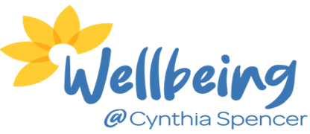

Family and Friends Cynthia Spencer Wellbeing Hub
- Do you support someone living with a life limiting condition?
- Do you provide emotional, practical, or personal care for a family member or friend living with a life limiting condition?
- Would you like to meet others in a similar situation and gain information, discuss relevant topics, and have support from staff?
- Do you feel you would benefit from assessment of your needs as a Carer?
If yes, then please come along to our twice monthly sessions. Sessions facilitated by Northamptonshire Carers and Wellbeing @ Cynthia Spencer team
a
2nd and 4th
January: 13th and 27th
February: 10th and 24th
March: 10th and 24th
April: 14th and 28th
May: 12th and 26th
June: 9th and 23rd

Tuesday of the month
10:30am – 12:00pm
Wellbeing @ Cynthia Spencer


Please contact us to book in to attend or to discuss the group further:
Wellbeing @ Cynthia Spencer Office: 03000 271256
Northamptonshire Carers Support Line: 01933 677907, option 2

